THE CHURCH OF THE HOLY FAMILY
Mills River, North Carolina
The Seventeenth Sunday after Pentecost October 2, 2022
Sacred Place +++ Sacred Space
Please observe silence after the altar candles are lit

PRELUDE Andante K545 by Mozart
A bell rings three times; the people stand

Presentation of the Word

ENTRANCE HYMN # 389 Let us, with a gladsome mind Let us, with a gladsome mind, praise the Lord, for he is kind: Refrain: for his mercies ay endure, ever faithful, ever sure.

Let us blaze his Name abroad,
for of gods he is the God: Refrain

He with all-commanding might
filled the new-made world with light: Refrain

He the golden-tress'd sun
caused all day his course to run: Refrain

The horn'd moon to shine by night,
mid her spangled sisters bright: Refrain

All things living he doth feed,
his full hand supplies their need: Refrain

Let us, with a gladsome mind, praise the Lord, for he is kind: Refrain OPENING ACCLAMATION
Celebrant Blessed be God: Father, Son, and Holy Spirit. People And blessed be God’s kingdom, now and for
ever. Amen.

COLLECT FOR PURITY
Almighty God, to you all hearts are open, all desires known, and from you no secrets are hid: Cleanse the thoughts of our hearts by the inspiration of your Holy Spirit, that we may perfectly love you, and worthily magnify your holy Name; through Christ our Lord. Amen.
HYMN OF PRAISE #488 Be thou my vision, O Lord of my heart
Be thou my vision, O Lord of my heart; all else be nought to me, save that thou art thou my best thought, by day or by night, waking or sleeping, thy presence my light.

Be thou my wisdom, and thou my true word; I ever with thee and thou with me, Lord; thou my great Father; thine own may I be; thou in me dwelling, and I one with thee.

High King of heaven, when victory is won, may I reach heaven's joys, bright heaven's Sun! Heart of my heart, whatever befall, still be my vision, O Ruler of all.

THE COLLECT OF THE DAY
Celebrant The Lord be with you.
People And also with you. Celebrant Let us pray.
Almighty and everlasting God, you are always more ready to hear than we to pray, and to give more than we either desire or deserve: Pour upon us the abundance of your mercy, forgiving us those things of which our conscience is afraid, and giving us those good things for which we are not worthy to ask, except through the merits and mediation of Jesus Christ our Savior; who lives and reigns with you and the Holy Spirit, one God, for ever and ever. Amen.

FIRST READING: Lamentations 1:1-6
A Reading from the book of Lamentations.
How lonely sits the city that once was full of people! How like a widow she has become, she that was great among the nations! She that was a princess among the provinces has become a vassal. She weeps bitterly in the night, with tears on her cheeks; among all her lovers she has no one to comfort her; all her friends have dealt treacherously with her, they have become her enemies. Judah has gone into exile with suffering and hard servitude; she lives now among the nations, and finds no resting place her pursuers have all overtaken her in the midst of her distress. The roads to Zion mourn, for no one comes to the festivals; all her gates are desolate, her priests groan; her young girls grieve, and her lot is bitter. Her foes have become the masters, her enemies prosper, because the LORD has made her suffer for the multitude of her transgressions; her children have gone away, captives before the foe. From daughter Zion has departed all her majesty. Her princes have become like stags that find no pasture; they fled without strength before the pursuer.
Reader The Word of the Lord. People Thanks be to God.

PSALM: Psalm 137 Vs. 1-8
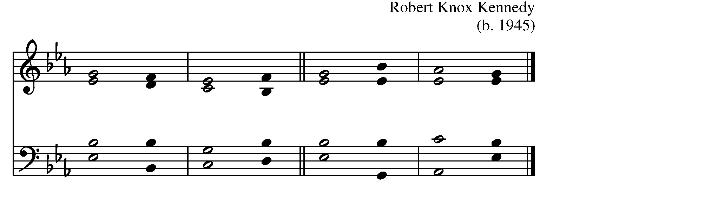
1 By the waters of Babylon we sat down and / wept, * when we remembered you, O / Zion. 2 As for our harps, we hung them / up * on the trees in the midst of that / land.
3 For those who led us away captive asked us for a song, and our oppressors called for / mirth: * “Sing us one of the songs of / Zion.” 4 How shall we sing the LORD’s / song * upon an alien / soil?
- If I forget you, O Je-/ rusalem, * let my right hand forget its / skill.
- Let my tongue cleave to the roof of my mouth if I do not remember / you, * if I do not set Jerusalem above my highest / joy.
- Remember the day of Jerusalem, O LORD, against the people of /Edom, * who said, “Down with it! down with it! even to the /ground!”
- O Daughter of Babylon, doomed to de-/ struction, * happy shall be the one who pays you back for what you have done to / us!

SECOND READING: 2 Timothy 1:1-14
A Reading from the Second letter to Timothy.
Paul, an apostle of Christ Jesus by the will of God, for the sake of the promise of life that is in Christ Jesus, To Timothy, my beloved child: Grace, mercy, and peace from God the Father and Christ Jesus our Lord. I am grateful to God—whom I worship with a clear conscience, as my ancestors did—when I remember you constantly in my prayers night and day. Recalling your tears, I long to see you so that I may be filled with joy. I am reminded of your sincere faith, a faith that lived first in your grandmother Lois and your mother Eunice and now, I am sure, lives in you. For this reason I remind you to rekindle the gift of God that is within you through the laying on of my hands; for God did not give us a spirit of cowardice, but rather a spirit of power and of love and of self-discipline. Do not be ashamed, then, of the testimony about our Lord or of me his prisoner, but join with me in suffering for the gospel, relying on the power of God, who saved us and called us with a holy calling, not according to our works but according to his own purpose and grace. This grace was given to us in Christ Jesus before the ages began, but it has now been revealed through the appearing of our Savior Christ Jesus, who abolished death and brought life and immortality to light through the gospel. For this gospel I was appointed a herald and an apostle and a teacher, and for this reason I suffer as I do. But I am not ashamed, for I know the one in whom I have put my trust, and I am sure that he is able to guard until that day what I have entrusted to him. Hold to the standard of sound teaching that you have heard from me, in the faith
and love that are in Christ Jesus. Guard the good treasure entrusted to you, with the help of the Holy Spirit living in us.
Reader The Word of the Lord. People Thanks be to God.

SEQUENCE HYMN #655 O Jesus, I have promised O Jesus, I have promised to serve thee to the end: be thou for ever near me, my Master and my friend; I shall not fear the battle, if thou art by my side, nor wander from the pathway, if thou wilt be my guide.

O let me hear thee speaking in accents clear and still, above the storms of passion, the murmurs of self-will; O speak to reassure me, to hasten or control; O speak, and make me listen, thou guardian of my soul.

O Jesus, thou hast promised to all who follow thee, that where thou art in glory there shall thy servant be; and, Jesus, I have promised to serve thee to the end; O give me grace to follow, my Master and my friend.

GOSPEL: Luke 17:5-10
Priest The Holy Gospel of our Lord Jesus Christ according to Luke.
People Glory to you, Lord Christ.
The apostles said to the Lord, “Increase our faith!” The Lord replied, “If you had faith the size of a mustard seed, you could say to this mulberry tree, ‘Be uprooted and planted in the sea,’ and it would obey you. “Who among you would say to your slave who has just come in from plowing or tending sheep in the field, ‘Come here at once and take your place at the table’? Would you not rather say to him, ‘Prepare supper for me, put on your apron and serve me while I eat and drink; later you may eat and drink’? Do you thank the slave for doing what was commanded? So you also, when you have done all that you were ordered to do, say, ‘We are worthless slaves; we have done only what we ought to have done!’ ” Priest The Gospel of the Lord.
People Praise to you, Lord Christ.

THE SERMON The Rev. Tracey Kelly
THE NICENE CREED
We believe in one God, the Father, the Almighty, maker of heaven and earth, of all that is, seen and unseen. We believe in one Lord, Jesus Christ, the only Son of God, eternally begotten of the Father,God from God, Light from Light, true God from true God, begotten, not made,of one Being with the Father. Through him all things were made. For us and for our salvation he came down from heaven: by the power of the Holy Spirit he became incarnate from the Virgin Mary, and was made man. For our sake he was crucified under Pontius Pilate; he suffered death and was buried. On the third day he rose again in accordance with the Scriptures; he ascended into heaven and is seated at the right hand of the Father. He will come again in glory to judge the living and the dead, and his kingdom will have no end. We believe in the Holy Spirit, the Lord, the giver of life, who proceeds from the Father and the Son. With the Father and the Son he is worshiped and glorified. He has spoken through the Prophets. We believe in one holy catholic and apostolic Church. We acknowledge one baptism for the forgiveness of sins. We look for the resurrection of the dead, and the life of the world to come. Amen.

THE PRAYERS OF THE PEOPLE
Leader Brothers and sisters, our help comes from the Lord. Let us pray, saying, “Lord, put your word within us; … Lord, write it on our hearts.”
When the leader says “Lord, put your word within us,” please respond “Lord, write it on our hearts.”

Celebrant Gracious God, author and giver of all good things, help us to hear, learn and embrace your word, so that we may live out our lives faithfully in your name, through Jesus Christ our Lord. Amen.

CONFESSION OF SIN
Let us confess our sins against God and our neighbor.
Most merciful God, we confess that we have sinned against you in thought, word, and deed, by what we have done, and by what we have left undone. We have not loved you with our whole heart; we have not loved our neighbors as ourselves. We are truly sorry and we humbly repent. For the sake of your Son Jesus Christ, have mercy on us and forgive us; that we may delight in your will, and walk in your ways, to the glory of your Name. Amen.
Almighty God have mercy on you, forgive you all your sins through our Lord Jesus Christ, strengthen you in all goodness, and by the power of the Holy Spirit keep you in eternal life. Amen.
THE PEACE
Celebrant The peace of the Lord be always with you. People And also with you.

GATHERING Halle Halle Halle

THE HOLY COMMUNION
OFFERTORY SENTENCE
Walk in love, as Christ loved us and gave himself for us, an offering and sacrifice to God. Ephesians 5:2

OFFERTORY When Peace Like A River Judy Rhodes

THE GREAT THANKSGIVING
Celebrant | The Lord be with you.
People | And also with you.
Celebrant | Lift up your hearts.
People | We lift them to the Lord.
Celebrant | Let us give thanks to the Lord our God.
People It is right to give God thanks and praise.
It is right, and a good and joyful thing, always and everywhere to give thanks to you, Father Almighty, Creator of heaven and earth. For by water and the Holy Spirit you have made us a new people in Jesus Christ our Lord, to show forth your glory in all the world.
Therefore we praise you, joining our voices with Angels and Archangels and with all the company of heaven, who for ever sing this hymn to proclaim the glory of your Name:

SANCTUS Holy, holy, holy
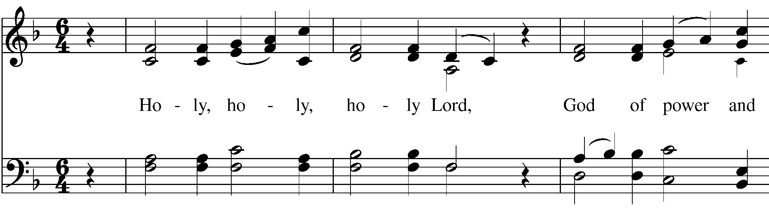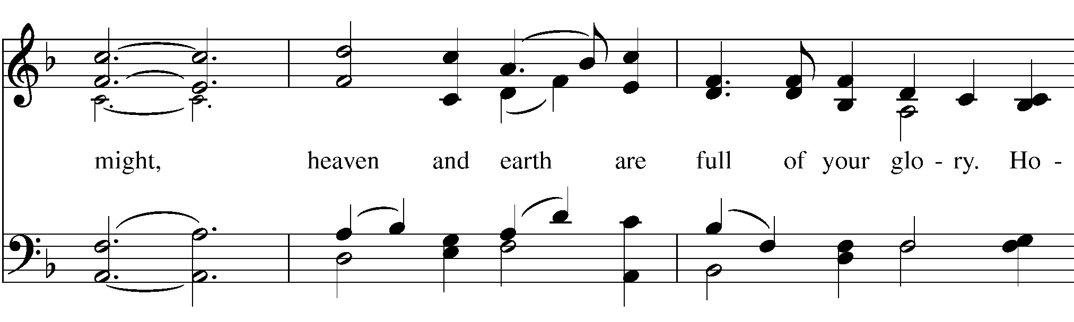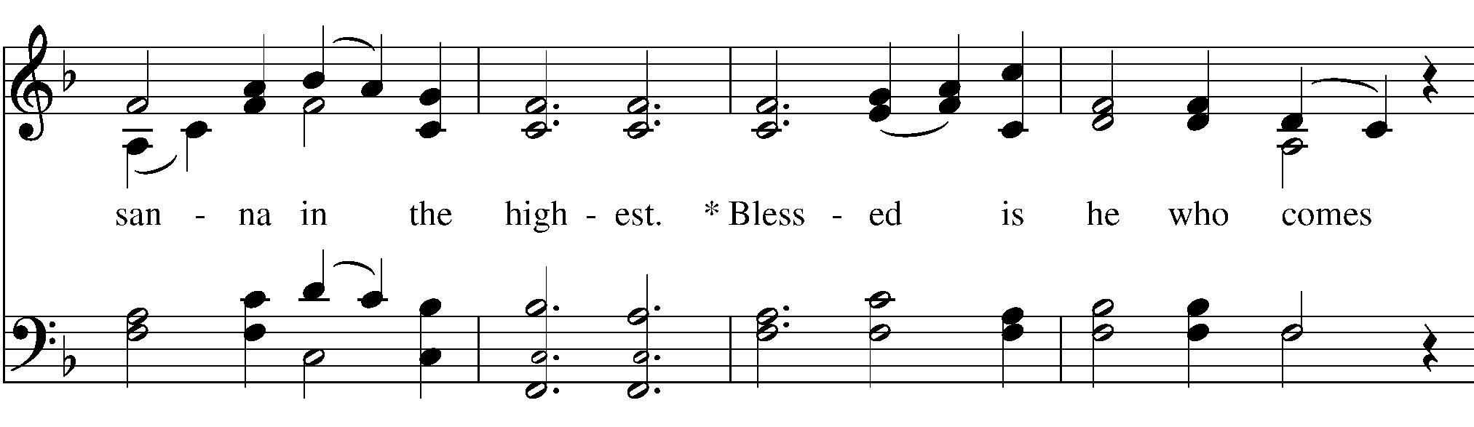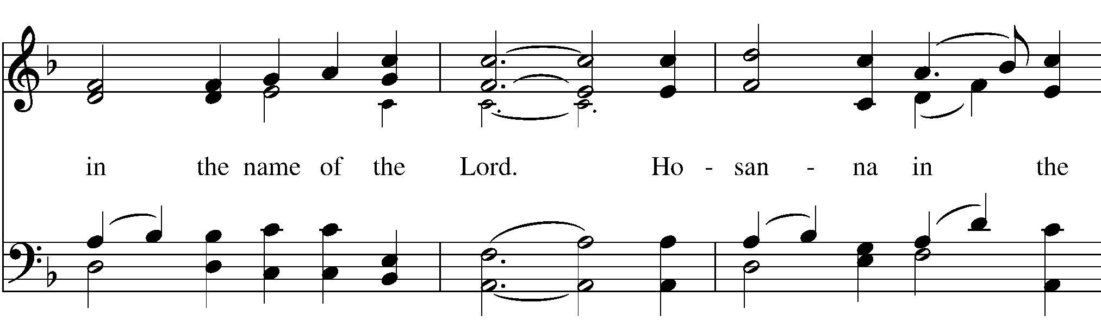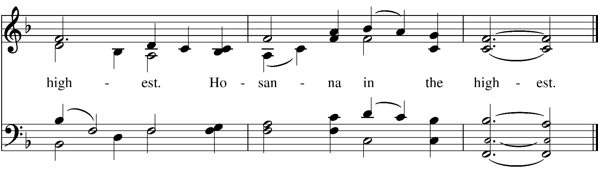

Holy and gracious Father: In your infinite love you made us for yourself; and, when we had fallen into sin and become subject to evil and death, you, in your mercy, sent Jesus Christ, your only and eternal Son, to share our human nature, to live and die as one of us, to reconcile us to you, the God and Father of all.
He stretched out his arms upon the cross, and offered himself in obedience to your will, a perfect sacrifice for the whole world.
On the night he was handed over to suffering and death, our Lord Jesus Christ took bread; and when he had given thanks to you, he broke it, and gave it to his disciples, and said, “Take, eat: This is my Body, which is given for you. Do this for the remembrance of me.”
After supper he took the cup of wine; and when he had given thanks, he gave it to them, and said, “Drink this, all of you: This is my Blood of the new Covenant, which is shed for you and for many for the forgiveness of sins. Whenever you drink it, do this for the remembrance of me.” Therefore we proclaim the mystery of faith:
Christ has died.
Christ is risen.
Christ will come again.
We celebrate the memorial of our redemption, O Father, in this sacrifice of praise and thanksgiving. Recalling his death, resurrection, and ascension, we offer you these gifts.
Sanctify them by your Holy Spirit to be for your people the Body and Blood of your Son, the holy food and drink of new and unending life in him. Sanctify us also that we may faithfully receive this holy Sacrament, and serve you in unity, constancy, and peace; and at the last day bring us with all your saints into the joy of your eternal kingdom.
All this we ask through your Son Jesus Christ. By him, and with him, and in him, in the unity of the Holy Spirit all honor and glory is yours, Almighty Father, now and for ever. AMEN.

THE LORD’S PRAYER
And now, as our Savior Christ has taught us, we are bold to say,
Our Father, who art in heaven, hallowed be thy Name, thy kingdom come, thy will be done, on earth as it is in heaven. Give us this day our daily bread. And forgive us our trespasses, as we forgive those who trespass against us. And lead us not into temptation, but deliver us from evil. For thine is the kingdom, and the power, and the glory, forever and ever. Amen.
THE BREAKING OF THE BREAD

FRACTION ANTHEM
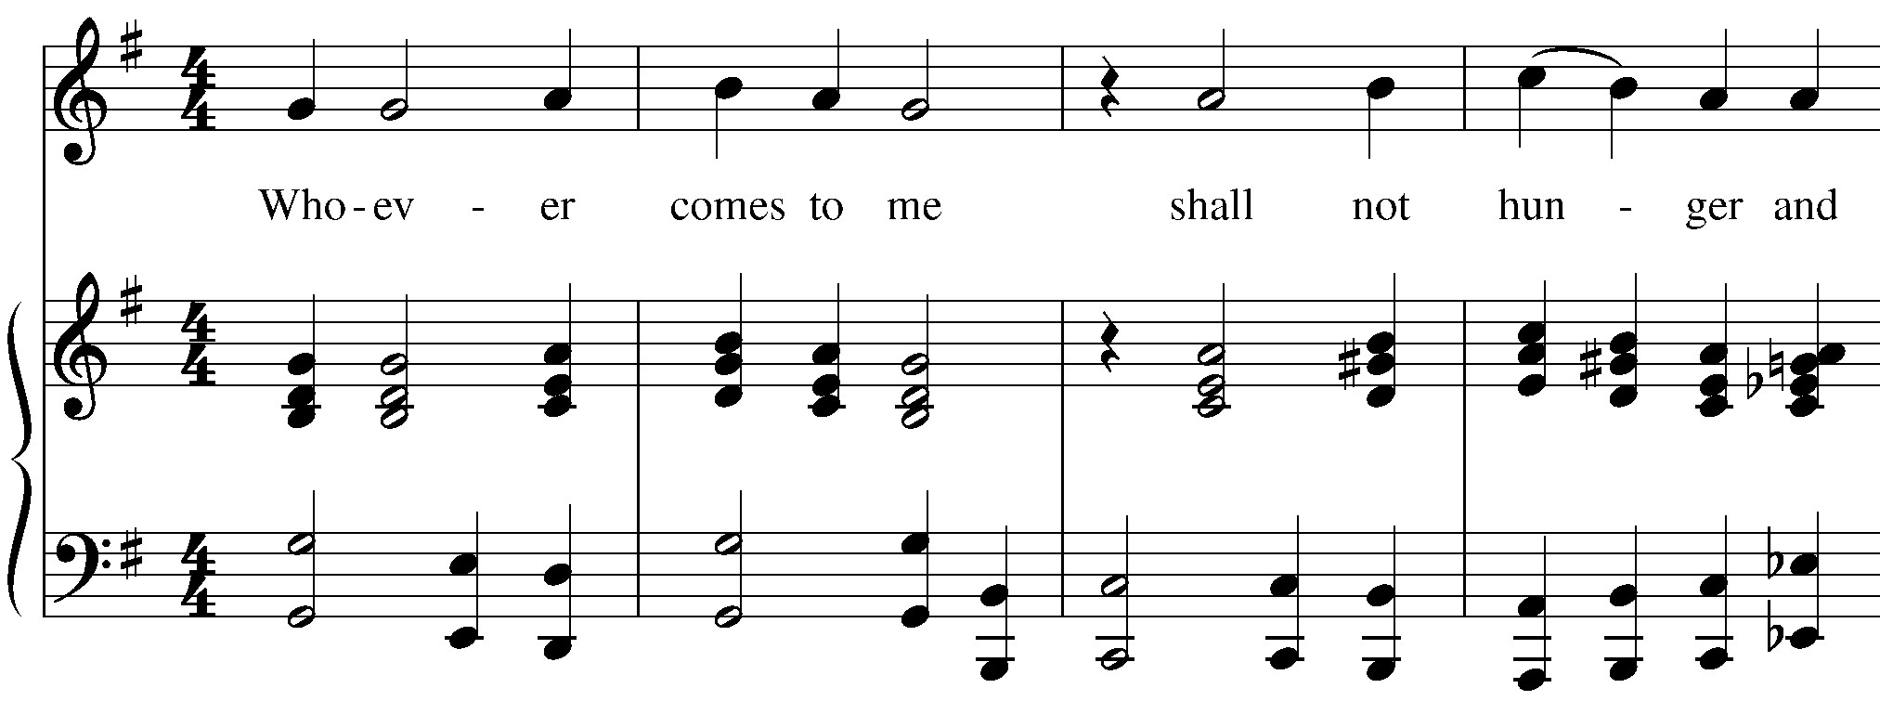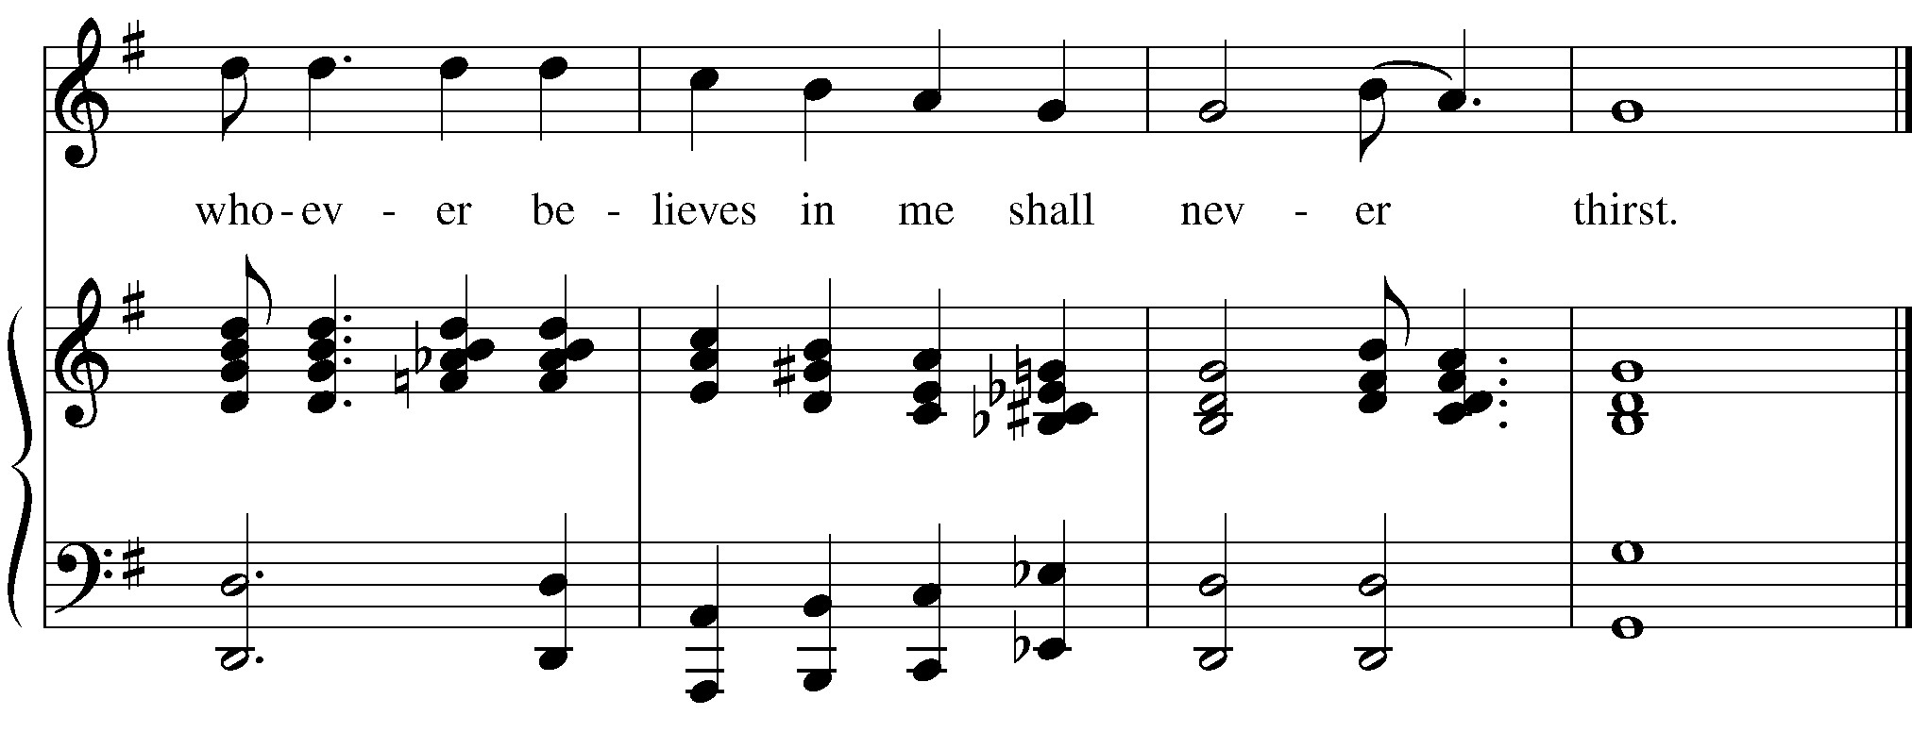

COMMUNION INVITATION The Gifts of God for the People of God. (The bread and wine are given to the people. Please indicate that you would prefer a gluten-free wafer by placing your hands with palms together when you come up to receive Communion.)

COMMUNION HYMN Eat This Bread Taize
Eat this bread, drink this cup, come to him and never be hungry.
Eat this bread, drink this cup, trust in him and you will not thirst.
Jesus Christ, bread of life, those who come to you will not hunger. Jesus Christ, Risen Lord, those who trust in you will not thirst.

POST-COMMUNION PRAYER
Let us pray.
Eternal God, heavenly Father, you have graciously accepted us as living members of your Son our Savior Jesus Christ, and you have fed us with spiritual food in the Sacrament of his Body and Blood. Send us now into the world in peace, and grant us strength and courage to love and serve you with gladness and singleness of heart; through Christ our Lord. Amen.
BLESSING
RECESSIONAL HYMN #551 Rise up, ye saints of God Rise up, ye saints of God! Have done with lesser things, give heart and soul and mind and strength to serve the King of kings.
Rise up, ye saints of God!
His kingdom tarries long:
Lord, bring the day of truth and love and end the night of wrong.
Lift high the cross of Christ! Tread where his feet have trod; and quickened by the Spirit's power, rise up, ye saints of God!
DISMISSAL

COMMUNITY ANNOUNCEMENTS
From riteplanning.com. Copyright © 2022 Church Publishing Inc. All rights reserved.

Hymns and service music are found in the blue hymnals found in the racks under the chairs.
Intercessory Prayer List: : Shirley, Mickey, Brent, Jim Br., Deborah and
Bob, Gary, Kathy S., Lisa L., Stan Ph., Richard, Mary B, Katie, Lou, Evelyn
S., Dave L., Linda Sue, Kevin, Nancy, Chris C., Jeanne
Upcoming Events:
2nd Tuesday of the month- Outreach Committee, 1:30 pm
Every Wednesday- Men’s Breakfast at Kosta’s, 9:00 am
2nd Saturday of the month- Women’s Group, 10:00 am
Every Wed., 4:00 pm- Choir Rehearsal

Please join us this afternoon at 4:00 pm for the Blessing of the Animals in celebration of the Feast of St. Francis!! Bring your pets and join in the festivities!

