THE CHURCH OF THE HOLY FAMILY
Mills River, North Carolina
The Fourteenth Sunday after Pentecost September 11, 2022
Sacred Place +++ Sacred Space
Please observe silence after the altar candles are lit

PRELUDE Sarabande in A Minor J. S. Bach
A bell rings three times; the People stand

Presentation of the Word

ENTRANCE HYMN #718 God of our fathers, whose almighty hand
God of our fathers, whose almighty hand leads forth in beauty all the starry band of shining worlds in splendor through the skies, our grateful songs before thy throne arise.

Thy love divine hath led us in the past, in this free land by thee our lot is cast; be thou our ruler, guardian, guide, and stay thy word our law, thy paths our chosen way.

From war's alarms, from deadly pestilence, be thy strong arm our ever sure defense; thy true religion in our hearts increase, thy bounteous goodness nourish us in peace.

Refresh thy people on their toilsome way, lead us from night to never-ending day; fill all our lives with love and grace divine, and glory, laud, and praise be ever thine.

OPENING ACCLAMATION
Blessed be God: Father, Son, and Holy Spirit.
People And blessed be God’s kingdom, now and for ever. Amen.

COLLECT FOR PURITY
Almighty God, to you all hearts are open, all desires known, and from you no secrets are hid: Cleanse the thoughts of our hearts by the inspiration of your Holy Spirit, that we may perfectly love you, and worthily magnify your holy Name; through Christ our Lord. Amen.

HYMN OF PRAISE #393 Praise our great and gracious Lord
Praise our great and gracious Lord, call upon his holy Name; raising hymns in glad accord, all his mighty acts proclaim: how he leads his chosen unto Canaan's promised land,
how the word we have heard firm and changeless still shall stand.

God has given the cloud by day, given the moving fire by night; guides his Israel on their way from the darkness into light. God it is who grants us sure retreat and refuge nigh; light of dawn leads us on:
'tis the Dayspring from on high.

THE COLLECT OF THE DAY
Celebrant The Lord be with you.
People And also with you.
Celebrant Let us pray.
O God, because without you we are not able to please you mercifully grant that your Holy Spirit may in all things direct and rule our hearts; through Jesus Christ our Lord, who lives and reigns with you and the Holy Spirit, one God, now and for ever. Amen.

FIRST READING: Jeremiah 4:11-12, 22-28
A Reading from the book of the prophet Jeremiah.
At that time it will be said to this people and to Jerusalem: A hot wind comes from me out of the bare heights in the desert toward my poor people, not to winnow or cleanse—a wind too strong for that. Now it is I who speak in judgment against them.“For my people are foolish, they do not know me; they are stupid children, they have no understanding. They are skilled in doing evil, but do not know how to do good.” I looked on the earth, and lo, it was waste and void; and to the heavens, and they had no light. looked on the mountains, and lo, they were quaking, and all the hills moved to and fro. I looked, and lo, there was no one at all, and all the birds of the air had fled. I looked, and lo, the fruitful land was a desert, and all its cities were laid in ruins before the LORD, before his fierce anger. For thus says the LORD: The whole land shall be a desolation; yet I will not make a full end. Because of this the earth shall mourn, and the heavens above grow black; for I have spoken, I have purposed; I have not relented nor will I turn back.
Reader The Word of the Lord. People Thanks be to God.

PSALM: Psalm 14
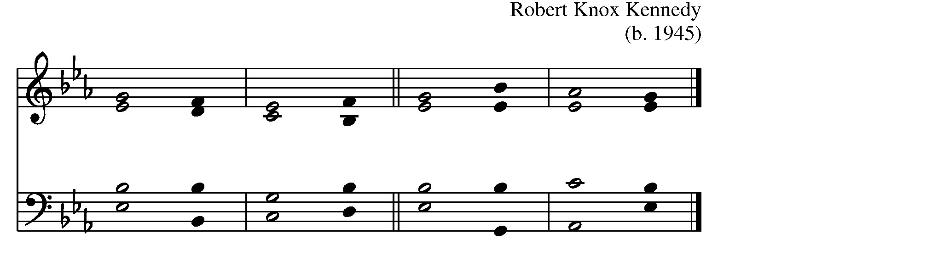
- The fool has said in his heart, “There is no / God.” * All are corrupt and commit abominable acts; there is none who does any / good.

- The LORD looks down from heaven upon us / all, *
to see if there is any who is wise, if there is one who seeks after / God.
- Everyone has proved faithless; all alike have turned / bad; * there is none who does good; no, not / one. 4 Have they no knowledge, all those evil-/ doers *
who eat up my people like bread and do not call upon the / LORD?
- See how they tremble with / fear, * because God is in the company of the / righteous.
- Their aim is to confound the plans of the af-/ flicted, * but the LORD is their / refuge.
- Oh, that Israel’s deliverance would come out of / Zion! * when the LORD restores the fortunes of his people, Jacob will rejoice and Israel be / glad.

SECOND READING: 1 Timothy 1:12-17
A Reading from the first letter to Timothy.
I am grateful to Christ Jesus our Lord, who has strengthened me, because he judged me faithful and appointed me to his service, even though I was formerly a blasphemer, a persecutor, and a man of violence. But I received mercy because I had acted ignorantly in unbelief, and the grace of our Lord overflowed for me with the faith and love that are in Christ Jesus. The saying is sure and worthy of full acceptance, that Christ Jesus came into the world to save sinners—of whom I am the foremost. But for that very reason I received mercy, so that in me, as the foremost, Jesus Christ might display the utmost patience, making me an example to those who would come to believe in him for eternal life. To the King of the ages, immortal, invisible, the only God, be honor and glory forever and ever. Amen.
Reader The Word of the Lord. People Thanks be to God.

SEQUENCE HYMN Will you come and follow me Verses 1-3
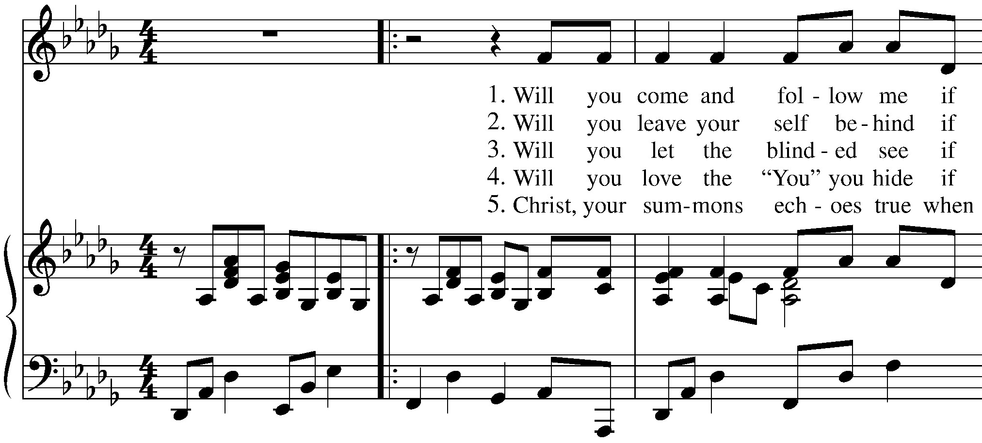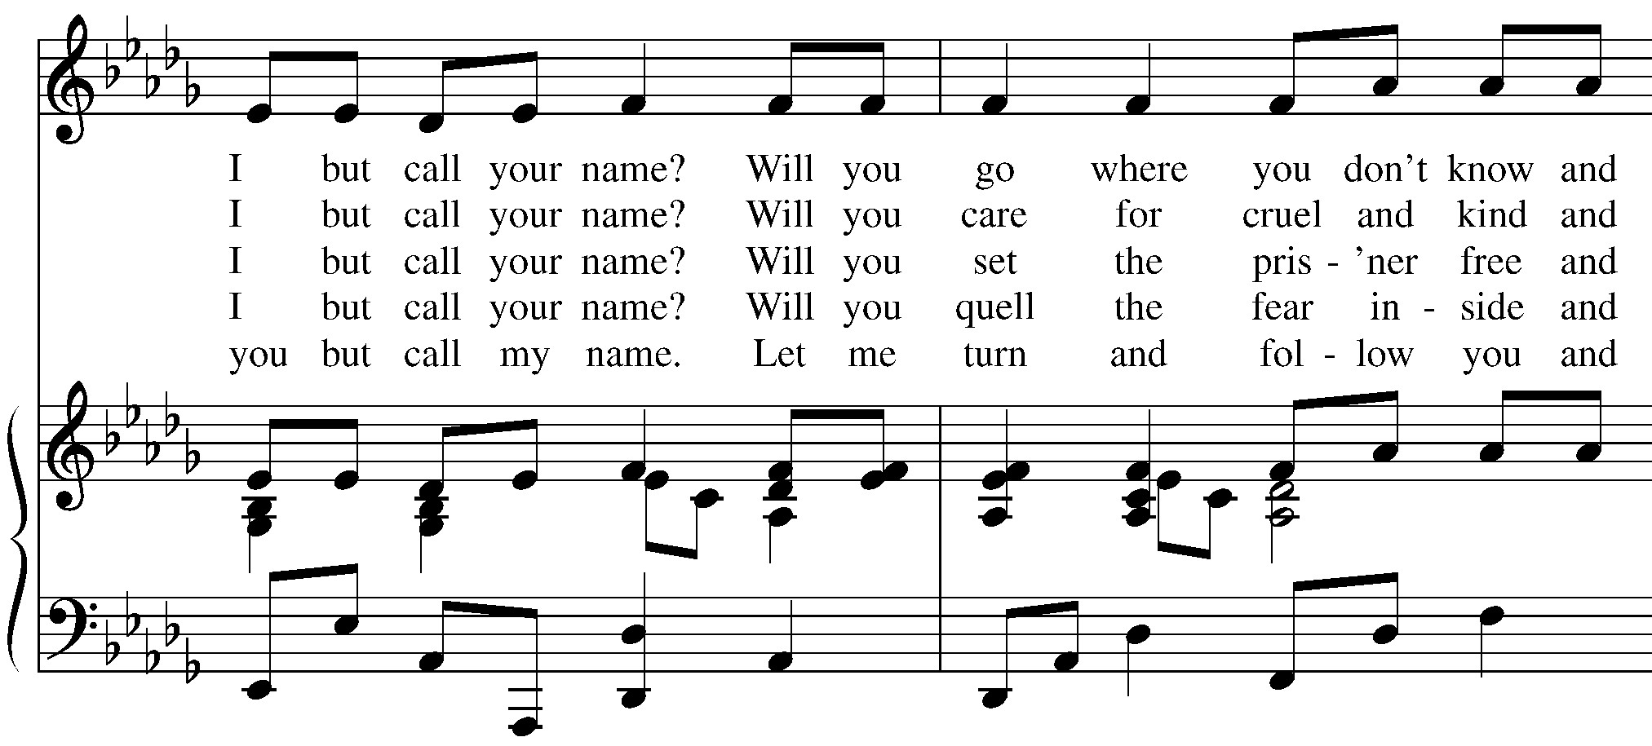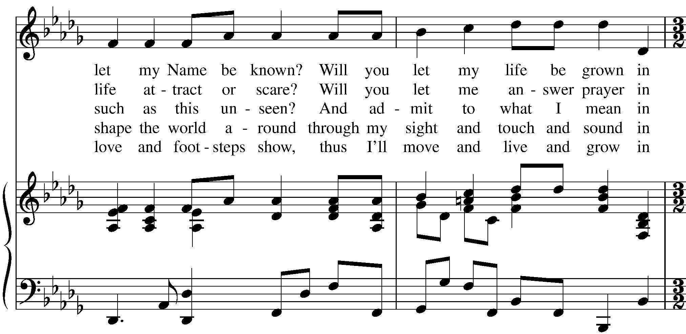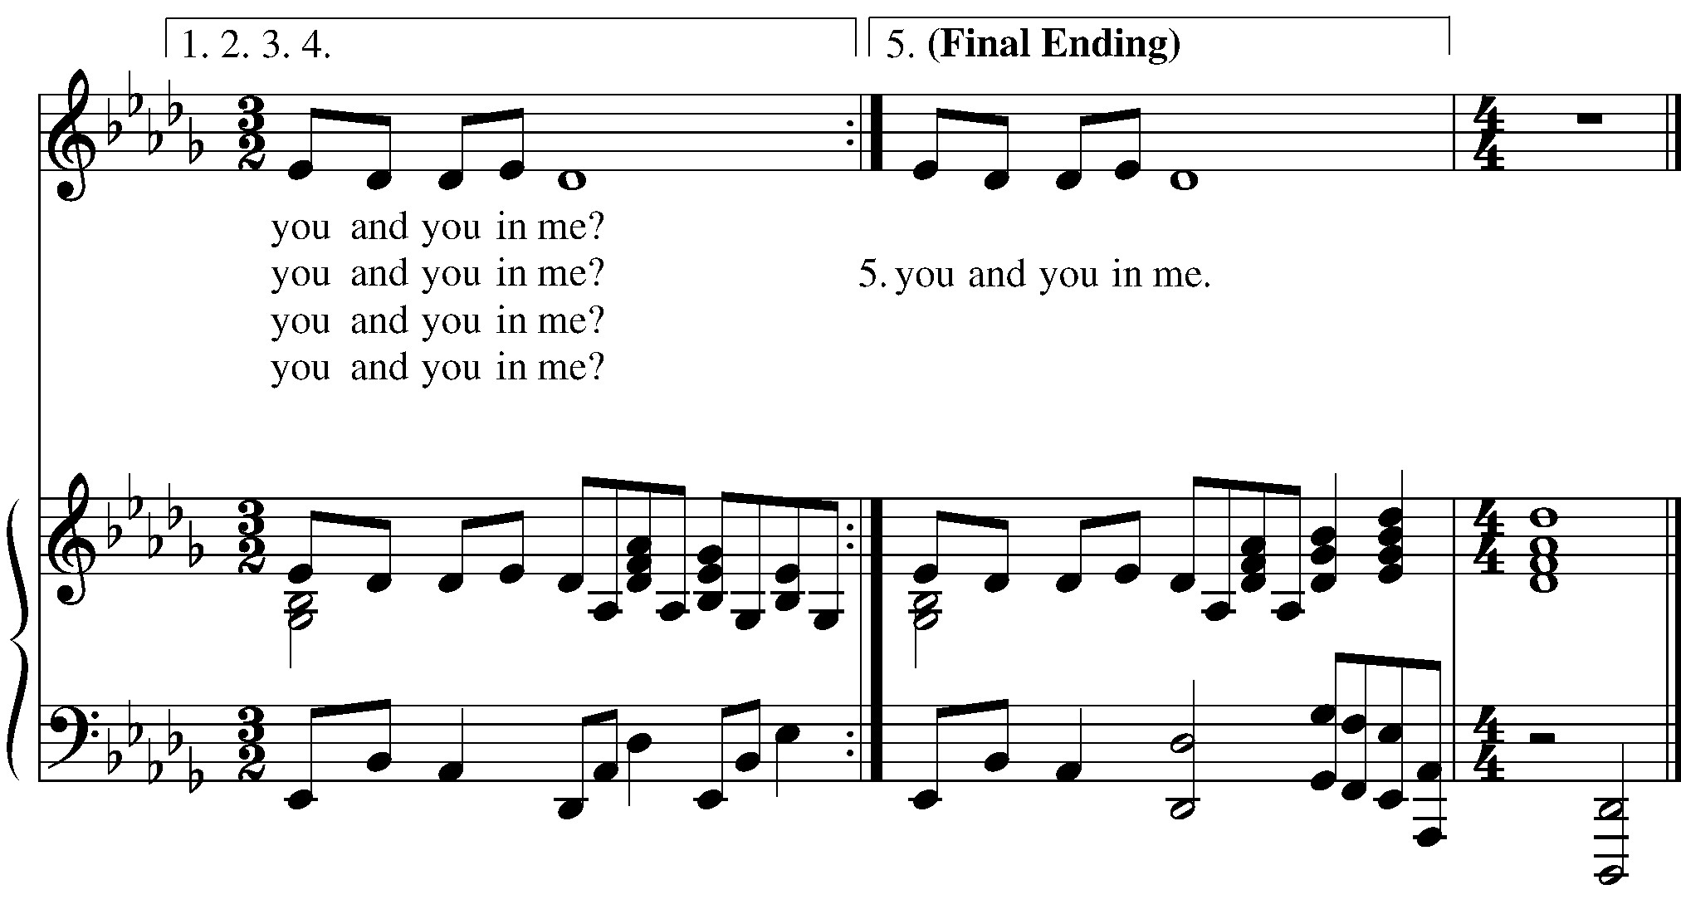

GOSPEL: Luke 15:1-10.
Priest The Holy Gospel of our Lord Jesus Christ according to Luke.
People Glory to you, Lord Christ.
Now all the tax collectors and sinners were coming near to listen to
[Jesus.] And the Pharisees and the scribes were grumbling and saying, “This fellow welcomes sinners and eats with them.” So he told them this parable: “Which one of you, having a hundred sheep and losing one of them, does not leave the ninety-nine in the wilderness and go after the one that is lost until he finds it? When he has found it, he lays it on his shoulders and rejoices. And when he comes home, he calls together his friends and neighbors, saying to them, ‘Rejoice with me, for I have found my sheep that was lost.’ Just so, I tell you, there will be more joy in heaven over one sinner who repents than over ninety-nine righteous persons who need no repentance. “Or what woman having ten silver coins, if she loses one of them, does not light a lamp, sweep the house, and search carefully until she finds it? When she has found it, she calls together her friends and neighbors, saying, ‘Rejoice with me, for I have found the coin that I had lost.’ Just so, I tell you, there is joy in the presence of the angels of God over one sinner who repents.” Priest The Gospel of the Lord. People Praise to you, Lord Christ.

THE SERMON The Rev. Tracey Kelly

THE NICENE CREED
We believe in one God, the Father, the Almighty, maker of heaven and earth, of all that is, seen and unseen. We believe in one Lord, Jesus Christ, the only Son of God, eternally begotten of the Father, God from God, Light from Light, true God from true God, begotten, not made, of one Being with the Father. Through him all things were made. For us and for our salvation he came down from heaven: by the power of the Holy Spirit he became incarnate from the Virgin Mary, and was made man. For our sake he was crucified under Pontius Pilate; he suffered death and was buried. On the third day he rose again in accordance with the Scriptures; he ascended into heaven and is seated at the right hand of the Father. He will come again in glory to judge the living and the dead, and his kingdom will have no end. We believe in the Holy Spirit, the Lord, the giver of life, who proceeds from the Father and the Son. With the Father and the Son he is worshiped and glorified. He has spoken through the Prophets. We believe in one holy catholic and apostolic Church. We acknowledge one baptism for the forgiveness of sins.We look for the resurrection of the dead, and the life of the world to come. Amen.

THE PRAYERS OF THE PEOPLE
Leader Brothers and sisters, our help comes from the Lord. Let us pray, saying, “Lord, put your word within us; … Lord, write it on our hearts.”
When the leader says “Lord, put your word within us,” please respond “Lord, write it on our hearts.”
A Prayer in Remembrance of September 11, 2001
Almighty God, years have passed but the events of September 11th are not forgotten. We remember this day your children of many nations and many faiths whose lives were cut short by fierce flames of anger and hatred. We remember those who were lost in the wars which followed. We lift up to you those who survived but were wounded in mind, body, and spirit. Console those who continue to suffer and grieve, and give them comfort and hope as they look to the future. Send your Spirit of peace on us and all of humanity, we pray, so that we may look for the coming of the peaceable Kingdom of God. We ask this in the name of Jesus Christ, our Lord, who lives and reigns with you, in the unity of the Holy Spirit, one God, for ever and ever. Amen.
Celebrant Gracious God, author and giver of all good things, help us to hear, learn and embrace your word, so that we may live out our lives faithfully in your name, through Jesus Christ our Lord. Amen.

CONFESSION OF SIN
Let us confess our sins against God and our neighbor.
Most merciful God, we confess that we have sinned against you in thought, word, and deed, by what we have done, and by what we have left undone. We have not loved you with our whole heart; we have not loved our neighbors as ourselves. We are truly sorry and we humbly repent. For the sake of your Son Jesus Christ, have mercy on us and forgive us; that we may delight in your will, and walk in your ways, to the glory of your Name. Amen.
Almighty God have mercy on you, forgive you all your sins through our Lord Jesus Christ, strengthen you in all goodness, and by the power of the Holy Spirit keep you in eternal life. Amen.

THE PEACE
Celebrant The peace of the Lord be always with you. People And also with you.

GATHERING Halle Halle Halle

The Holy Communion

OFFERTORY SENTENCE
Walk in love, as Christ loved us and gave himself for us, an offering and sacrifice to God. Ephesians 5:2
OFFERTORY Go Down, Moses By Marion Williams

THE GREAT THANKSGIVING
Celebrant | The Lord be with you.
People | And also with you.
Celebrant | Lift up your hearts.
People | We lift them to the Lord.
Celebrant | Let us give thanks to the Lord our God.
People | It is right to give God thanks and praise.
It is right, and a good and joyful thing, always and everywhere to give thanks to you, Father Almighty, Creator of heaven and earth. For by water and the Holy Spirit you have made us a new people in Jesus Christ our Lord, to show forth your glory in all the world.
Therefore we praise you, joining our voices with Angels and Archangels and with all the company of heaven, who for ever sing this hymn to proclaim the glory of your Name:

SANCTUS Holy, holy, holy
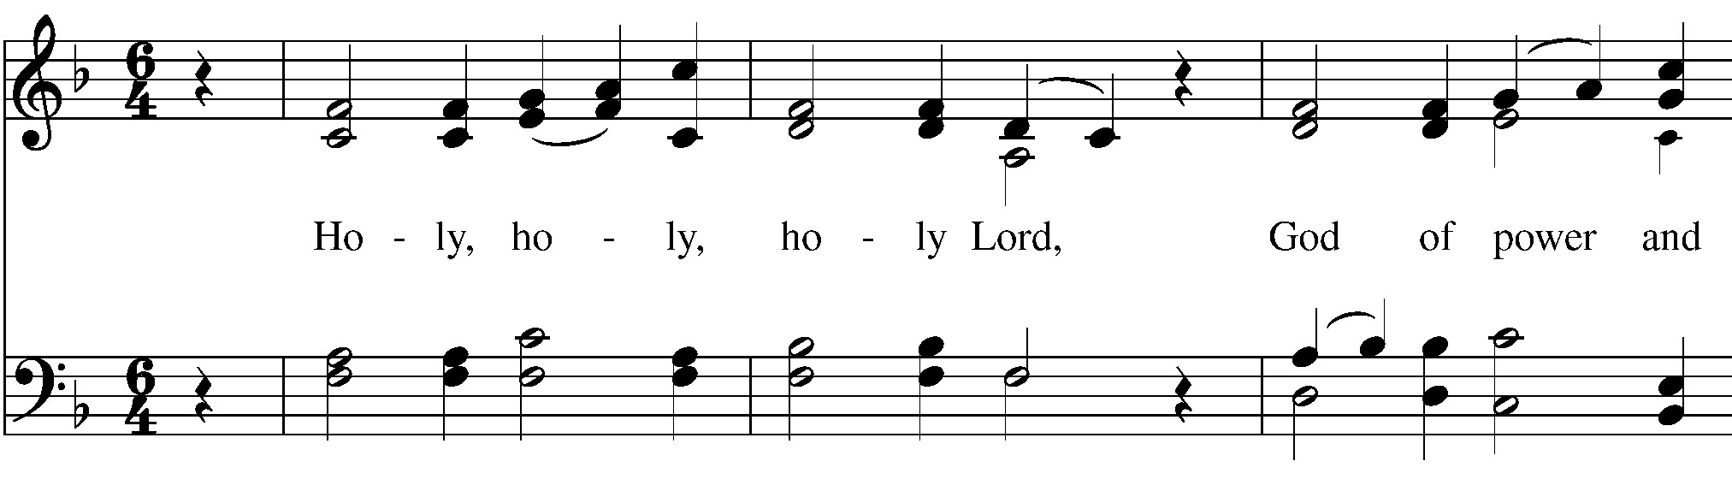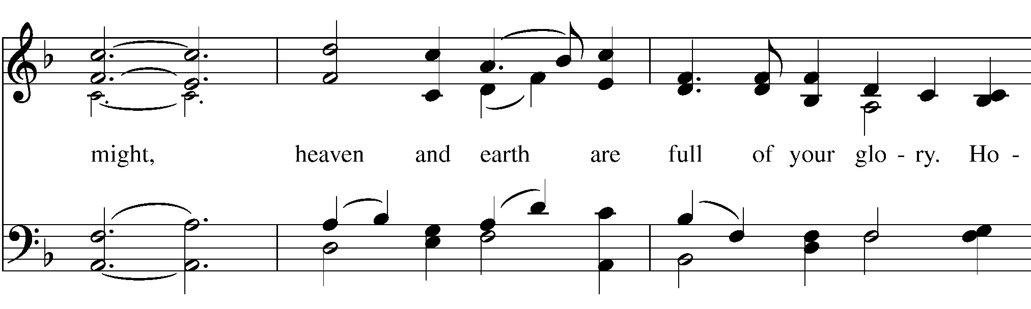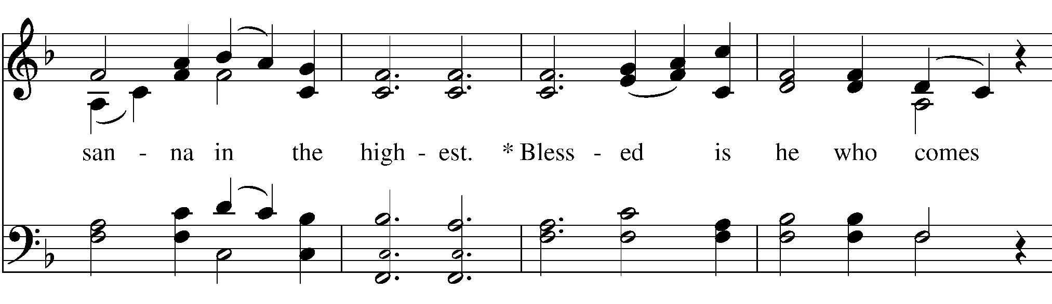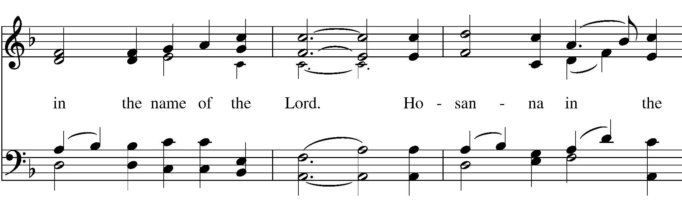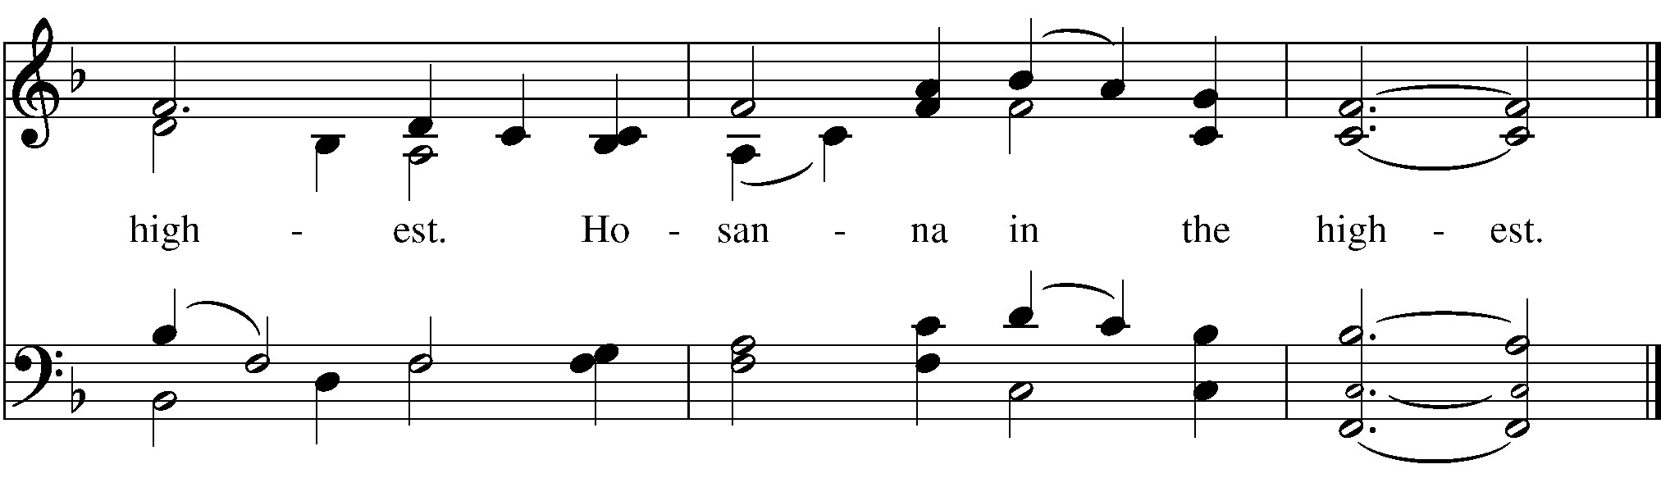

Holy and gracious Father: In your infinite love you made us for yourself; and, when we had fallen into sin and become subject to evil and death, you, in your mercy, sent Jesus Christ, your only and eternal Son, to share our human nature, to live and die as one of us, to reconcile us to you, the God and Father of all.
He stretched out his arms upon the cross, and offered himself in obedience to your will, a perfect sacrifice for the whole world.
On the night he was handed over to suffering and death, our Lord Jesus Christ took bread; and when he had given thanks to you, he broke it, and gave it to his disciples, and said, “Take, eat: This is my Body, which is given for you. Do this for the remembrance of me.”
After supper he took the cup of wine; and when he had given thanks, he gave it to them, and said, “Drink this, all of you: This is my Blood of the new Covenant, which is shed for you and for many for the forgiveness of sins. Whenever you drink it, do this for the remembrance of me.” Therefore we proclaim the mystery of faith:
Christ has died.
Christ is risen.
Christ will come again.
We celebrate the memorial of our redemption, O Father, in this sacrifice of praise and thanksgiving. Recalling his death, resurrection, and ascension, we offer you these gifts.
Sanctify them by your Holy Spirit to be for your people the Body and Blood of your Son, the holy food and drink of new and unending life in him. Sanctify us also that we may faithfully receive this holy Sacrament, and serve you in unity, constancy, and peace; and at the last day bring us with all your saints into the joy of your eternal kingdom.
All this we ask through your Son Jesus Christ. By him, and with him, and in him, in the unity of the Holy Spirit all honor and glory is yours, Almighty Father, now and for ever. AMEN.

THE LORD’S PRAYER
And now, as our Savior Christ has taught us, we are bold to say,
Our Father, who art in heaven, hallowed be thy Name, thy kingdom come, thy will be done, on earth as it is in heaven. Give us this day our daily bread. And forgive us our trespasses, as we forgive those who trespass against us. And lead us not into temptation, but deliver us from evil. For thine is the kingdom, and the power, and the glory, forever and ever. Amen.

THE BREAKING OF THE BREAD

FRACTION ANTHEM
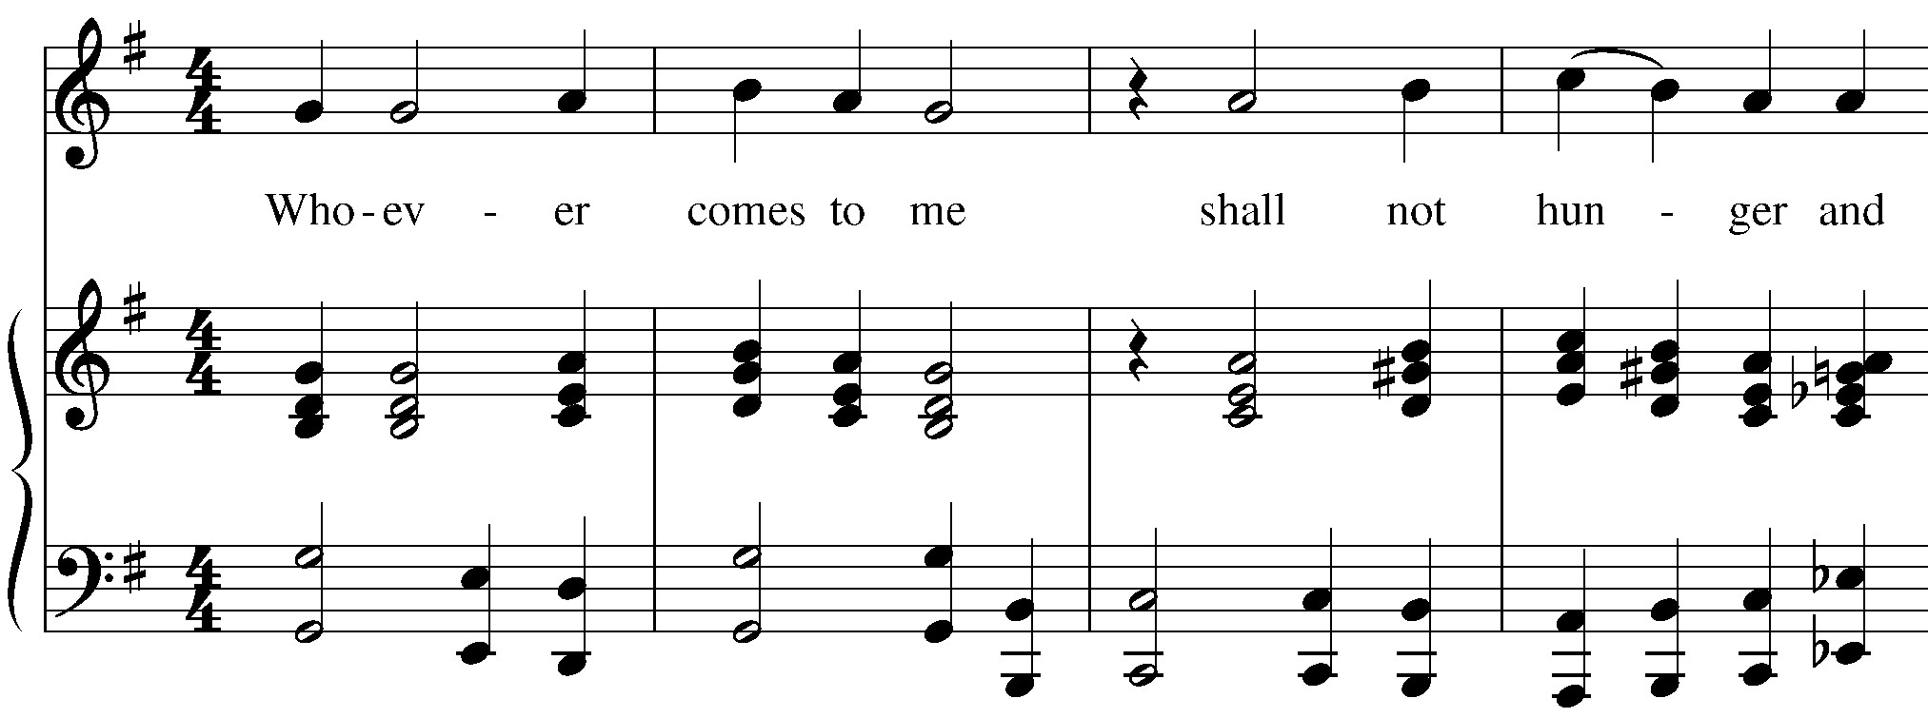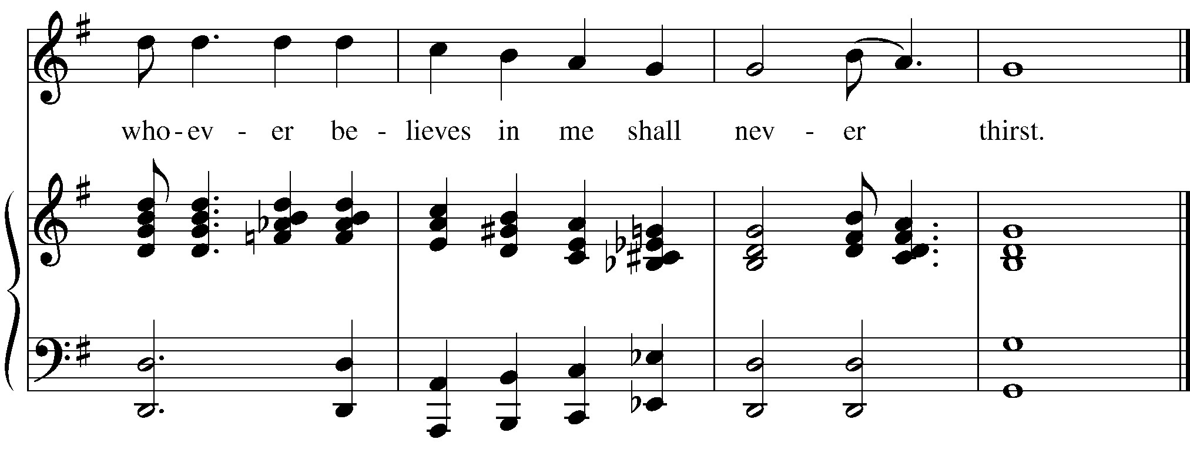

COMMUNION INVITATION The Gifts of God for the People of God. (The bread and wine are given to the people. Please indicate that you would prefer a gluten-free wafer by placing your hands with palms together when you come up to receive Communion.)

COMMUNION HYMN #645 The King of love my shepherd is
The King of love my shepherd is, whose goodness faileth never; I nothing lack if I am his, and he is mine for ever.

Where streams of living water flow, my ransomed soul he leadeth, and where the verdant pastures grow, with food celestial feedeth.

Perverse and foolish oft I strayed, but yet in love he sought me, and on his shoulder gently laid, and home, rejoicing, brought me.

In death's dark vale I fear no ill with thee, dear Lord, beside me; thy rod and staff my comfort still, thy cross before to guide me.

Thou spread'st a table in my sight; thy unction grace bestoweth; and oh, what transport of delight from thy pure chalice floweth!

And so through all the length of days thy goodness faileth never:
Good Shepherd, may I sing thy praise within thy house for ever.

POST-COMMUNION PRAYER
Let us pray.
Eternal God, heavenly Father, you have graciously accepted us as living members of your Son our Savior Jesus Christ, and you have fed us with spiritual food in the Sacrament of his Body and Blood. Send us now into the world in peace, and grant us strength and courage to love and serve you with gladness and singleness of heart; through Christ our Lord. Amen. BLESSING

RECESSIONAL HYMN #448 O love, how deep, how broad, how high
Vs. 1-3 and 6
O love, how deep, how broad, how high, how passing thought and fantasy, that God, the Son of God, should take our mortal form for mortals' sake.
For us baptized, for us he bore his holy fast and hungered sore; for us temptations sharp he knew; for us the tempter overthrew.

For us he prayed; for us he taught; for us his daily works he wrought: by words and signs and actions, thus still seeking not himself, but us.

All glory to our Lord and God for love so deep, so high, so broad; the Trinity whom we adore for ever and for evermore.

DISMISSAL

COMMUNITY ANNOUNCEMENTS
From riteplanning.com. Copyright © 2022 Church Publishing Inc. All rights reserved.

Hymns and service music are found in the blue hymnals found in the racks under the chairs.
Intercessory Prayer List: : Shirley, Mickey, Brent, Jim Br., Deborah and
Bob, Gary, Kathy S., Lisa L., Stan Ph., Richard, Mary B, Katie, Lou, Evelyn
S., Dave L., Linda Sue
Upcoming Events:
2nd Tuesday of the month- Outreach Committee, 1:30 pm
Every Wednesday- Men’s Breakfast at Kosta’s, 9:00 am
2nd Saturday of the month- Women’s Group, 10:00 am Every Wed., 4 pm- Choir Practice

